Fact Sheet on Stroke
Definition
Stroke is a condition in which blood supply to the brain is interrupted leading to damage of the brain cells. Stroke is among the collection of illnesses, disorders, and ailments that affect blood vessels and body fluid supply to the head. When a person has a stroke, either a part of the blood vessels transporting oxygen and nutrients to the head is blocked by a clot or it has busted, preventing some parts of the brain from receiving necessary oxygen and nutrients for the nourishment of the brain cells. The cells therefore die and the functionality of the brain is impaired, leading to malfunction of a section of the general body. The good news is that eighty percent of stroke conditions are preventable and treatable.

Varying Levels/Classifications of Disability
There are three major types of stroke according to the Center for Disease Control (CDC), namely;
- Ischemic Stroke
This is the most occurring type of stroke with a frequency of 87% of all the strokes. It arises when the blood going to the brain through an artery is obstructed. It occurs in different forms depending on the location of the clot. For instance, a thrombotic stroke occurs when an artery becomes narrow over time due to the buildup of cholesterol, leading to a plaque that raptures forming clots. Also, an embolic stroke occurs when debris (a piece of fatty material) and clots traveling within the bloodstream blocks an artery in its path.
- Hemorrhagic Stroke
It occurs when there is a blood leak from an artery because of the rapture of brain arteries. The leak puts a lot of pressure on the brain cells, damaging them. Hemorrhagic stroke results from high blood pressure and aneurysms (balloon-like bulges in the arteries) both of which cause stretching of the arteries leading to bursting. Hemorrhagic stroke occurs in two different forms including Intracerebral hemorrhage (occurs when brain artery bursts causing blood-flood in the surrounding tissue) and Subarachnoid hemorrhage (which is the bleeding in the zone between the brain and tissues wrapping it)
- Transient Ischemic Attack (TIA)
TIA is also referred to as a ‘Mini Stroke’ and it results from blockage of blood from reaching the brain cells for short periods of about 5minites. It should be taken seriously since it provides a warning for a growing stroke.
.

Causes of Disability
The main cause of stroke is Ischemia and hemorrhage in the brain cells. When there is blockage of an artery by a blood clot (thrombosis), brain part supplied with the blocked blood is deprived of oxygen and nutrients, and therefore, the cells die and the body parts controlled by that section of the brain stop functioning. Furthermore, calcium and fat deposits can break loose from the walls of the artery and the heart, and then be transported to the brain through the bloodstream where they cause a blockage. Finally, pressure buildup in the arteries in the heart may cause them to burst, causing leaks within the brain. The flooding of the blood in the brain causes the squeezing of the brain against the skull leading to further tissues and cell damage. Many people are at risk of suffering stroke but the most exposed are the ones having primary illnesses like high blood pressure, high cholesterol diabetes, smokers, and people with arterial fibrillation.

Motor Characteristics Related to the Disability
Stroke directly affects the functionality of the brain; this has significant effects on the quality of life of the survivor following that all body functions are directly linked to the brain. Therefore, depending on the extent and the section of the brain affected, the motor skills and abilities of the patient are likely to suffer in the following ways
- Restricted physical movement abilities
- Slowed communication abilities and impaired speech
- General body weakness
- Paralysis of the limbs (one side of the body)
- Inability to grip and hold objects
Cognitive Characteristics Related to the Disability
Recent research done indicate that patients who recovered from stroke have cognitive impairments and memory dysfunctions about the stroke location in the brain.
- About 30% of stroke patients develop dementia. Post-stroke patients have memory decline and are unable to relate time, language, attention.
- Prominent memory problems such as memory loss.
Social Characteristics Related to the Disability
Most of the functional body abilities deteriorate during and after stroke. A stroke patient feel confused, helpless, grief, anger, and depressed. According to the data by Stroke Rehabilitation Center, stroke patients are socially isolated with decreased community involvement. Besides, there is an economic strain on the family and disruption of functions plus poor motivation due to increased dependency by the patient. The patient's family relationships, sexual life, and leisure activities deteriorate significantly.
Health Problems Related to the Disability
Stroke harms the entire body organ systems. Stroke has long-lasting health effect on
- Breathing System
Once the part of the brain that controls ingestion and swallowing is affected, then one can have problems with dysphagia. Besides, stroke is likely to result in a coma or death due to breathing problems when the brain stem is affected.
- Nervous system
The nervous system needs response signals from the brain to initiate muscular responses of the body. When the brain is damaged, these important signals are not sent to the nervous system, leading to incorrect interpretation of messages. The effects are abnormal feelings of pain, body temperatures, and inaccurate vision. Nevertheless, motor movements become impaired, making it difficult to lift the front parts of the foot and hands.
Damage to different parts of the brain affects different body functions. For instance, destruction of the frontal brain lobe causes changes in intelligence, motor abilities, and logical character traits. Destruction to the right side can result in the loss of responsiveness, focus, remembrance issues, and recognition of faces and objects. If the left side is affected, the person experiences difficulty in speaking and understanding language, and trouble reasoning, organizing, thinking.
- Muscular system
Stroke affects different varieties of muscles, ranging from minor to major problems requiring rehabilitation. When the lefts side of the brain is damaged by the stroke, the right side of the body experiences the effects of numbness and paralysis due to weakness of the muscles. The patient tends to lose balance and experiences post-stroke fatigue.
- Digestive system
Constipation is one of the side effects of stroke medications. Besides, the brain controls the bowel, and the effect on the brain part carrying out digestive activities may cause inconsistencies in the bowel functions.
- Urinary system
Breakdown of communication between the brain, the nervous system, and muscle activity may result in a malfunction of the bladder.
- Reproductive system
Stroke changes the feeling of pleasure, thereby leading to decreased sexual activity and feelings. Depression and some of the stroke medications also decrease the patient's sexual desires. The main effect of stroke is paralysis, which is the major health problem resulting in all the other health issues.

Problem Guidelines and Principles
Stroke is considered a lifestyle disease because a higher percentage of the population contract the disease because of not taking care of their lives. In this context, people must watch how they live. To prevent stroke, certain things have to watch. Lifestyle and environmental factors are determinants of the prevention of stroke.
- Eating a healthier meal
- Regularly physical activity
- Upholding a healthy body mass
- Avoid smoking
- Regulating the liquor content that one consumes.
- Practicing these activities guarantees that one will have a longer life that is free from chronic diseases such as stroke.

Instructional Techniques and Activities
- Feeble muscles that fatigue easily during day-to-day exercise should not be pressed by reinforcement.
- The muscle functioning at full strength usually achieves unchanging activities
- If the patient feels weaker after or if fatigue lasts longer than usual then strength training has exceeded its limits.

Specialized Equipment of Modification Commonly Used or Related to Disability
Walking aids like canes, strollers (offer aid with stability and stamina), braces (Orthosis for help to maintain function and comfort, wheelchairs, and communication Devices like a notebook, Magic Slate Board, alphabet boards (useful communication aid available when writing abilities are lost), and alerting system.
Additional Modified At Home Equipment:
- Grab bars
- Guard rails
- Safety rails
- Ramps
- Stairlifts
- Porch lifts

Questions
- Stroke is one of the many heart-related problems. Name at least three other heart-related diseases or conditions
- What is the common cause of a stroke? Is stroke curable?
- What part of the body is mainly affected by stroke?
- Briefly explain the three types of stroke?
- Can high blood pressure cause stroke? Explain?

Individual Exercise Program (IEP)
Client’s Name: Magdalene Iglesias
Age: 65
Primary Disability: Paralysis on the right side of the body
The client is Assessments:
Magdalene has been diagnosed with a mild stroke because she was feeling numb on the right side of her body for the last couple of weeks. She fell while doing dishes in her kitchen two weeks ago hence we were forced to take her to the hospital where she was diagnosed with mild stroke.
The fact that Magdalene is a secretary, she interacts with different people which makes her very much active at work hence, she does a lot of communication with people hence has an active life at work. She could to susceptible to any kind of disease because she spends a lot of time at work and it's always when she is seated. The moment she arrives home, she is alone because her kids are adults and her husband died five years ago.
Strengths:
Weaknesses:

Duration of services:
Magdalene will receive therapy from 08/20/2019 to 10/30/2019 at the California Home for the elderly in California from 2:00 pm to 4:00 pm daily.
Position Responsible:
- Physiotherapist
- Self-responsible for exercises at home
- The trainer may help with exercises at home and additional motivation.
A. Long-Term Instructional Objective:
Magdalene will increase her movement activities by engaging in activities such as walking within the park after work rather than resting at home. Exercising will mean that she makes her body active hence; her right side of the body becomes active.
Short-Term Instructional Objective | Criteria | Schedule for Evaluation | Results
While at home, she raises her right hand and lowers it after every 30 seconds. | Magdalene needs to prove that her right side of the body is responding to any kind of motivation that it is given. She should constantly stand, raise her right hand than her right leg after thirty minutes of rest. | August 20th , 2019 (1st visit) | Magdalene was able to perform the tasks allocated to her. She could raise her right hand as well as her right leg with an interval of 30 minutes for three hours.

Modifications:
The first couple of weeks were hard on her because she was not mentally prepared to tackle such a challenge and the fact she was still in denial.
Safety Strategies:
The trainer also has to make sure that Magdalene follows her plan diligently because failure to do so will mean that she starts afresh. The painkillers she has to take will include paracetamol and the prescribed drugs by the doctor. Meanwhile, she has to be assisted for her to walk effectively.
B. Long-Term Instructional Objective

Short-Term Instructional Objective | Criteria | Schedule for Evaluation | Results
The next exercise is to make sure she can pick an object from the ground with her right hand to strengthen her hand. | For the whole day, she has to undertake this objective thrice. Once in the morning, noontime, and in the evening. | September. 3, 2019 (2nd visit) | Magdalene was able to effectively undertake the tasks that she was given which were a positive

Modifications:
Magdalene was able to undertake the tasks required of her for the required period hence the physiotherapist decided to give her a complex challenge.
Safety Strategies:
While conducting such an objective, the trainer has to present and make sure that the patient does not overdo what is required of them or otherwise perform her tasks wrongly making her entirely paralyzed. In the long run, Magdalene is expected to be able to perform the basic functions with her right side of the body

C. Long-Term Instructional Objective

Short-Term Instructional Objective | Criteria | Schedule for Evaluation | Results
The next exercise is to make sure she can stand up from the ground to strengthen her hand. | For the half a day, she has to undertake this objective twice. Once in the morning, and in the evening. | October. 25, 2019 (3rd visit) | Magdalene was able to effectively undertake the tasks that she was given which were a positive

Exercise Plan
Client’s Name: Magdalene Iglesias
Age: 65
Primary Disability: Paralysis on the right side of the body
Short-Term Instructional Objectives:
- While in a sitting position,
- Magdalene will try to lift her arm at shoulder height
- Magdalene will have her right foot stretched back and forth (repeat on her right arm with help of a person when the physiotherapist is not around for an appointment)
- Magdalene will start to perform second-level strength training. This starts with her trying to keep her right arm on air for 2 minutes.
- Magdalene needs to undertake advanced second-level strengthening exercises along with the resistance band exercises.
- She will now begin to do the exercise standing up for more than two minutes.
- Magdalene will now begin to try on balance exercises along with a few muscle endurance exercises. Magdalene will do this by balancing on her right side of the body for ten seconds three times a day while supporting herself with a stretcher and an assistant to have a perfect balance.
What and how the instructor will implement objectives including safety and systematic detailed instruction for:
A. Warm-up
Implement Objectives
- The trainer will explain why she has warm up before embarking on more intense exercise so as not to have any further injuries when exercising.
- The instructor will have modification for Magdalene because of her condition
- When warming up moderate pace will be advisable.
- Warm-up will target the muscles that will be used during the workout
Equipment Needed
Crotchet
Safety
The area that Magdalene undertakes her activities should be properly checked to ensure that any external forces do not harm her.

B. Stretching
Implement Objectives
- Stretching the right arm back and forth
- Carrying light objects with the right hand while seated for 3 minutes
- Move the right leg up and down while seated.
Equipment Needed:
Lightweights
Safety Measures
The instructor has to make sure that the equipment used by the client is of the right measurements. Besides, the trainer has to make sure that the client undertakes the exercises are required without compromise. The trainer has to supervise the exercise procedure.

C. Workout
Implement Objectives
- The implementation of this strategy is to make sure that the patient can now stand and move on their own without straining and moving with the crotchets.
Equipment Needed:
Crotchets
Safety Measures
Walking in the park for more than ten minutes without supervision.
The stand will the left leg for a minute and the right leg for thirty seconds.
Be able to carry slightly heavier equipment for ten seconds.
Stand on the right leg for more than thirty seconds.

D. Cooling Down.
Implement Objectives
- The Patient should be able to rest at the end of the exercises
- Stretch back to normal body activities
Equipment needed:
- Music
- Water
- Fruits
- Trash bags

Qualifications for a Trainer
- Must be a qualified physiotherapist
- Must have experience of more than three years
- Must be a good communicator.
- Must know when to provide extra support to the individual when needed
- Must know the signs of the onset of pain in the individual performing the exercises.

Diagrams

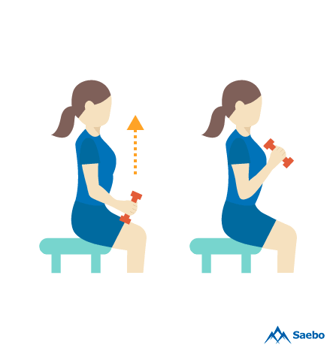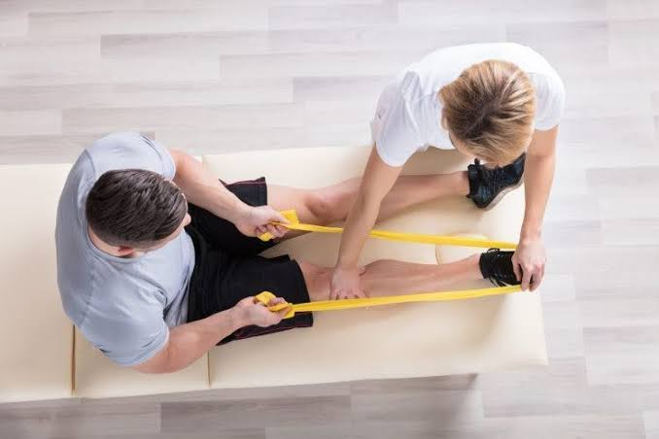
(a) Small weight lifts (c) Leg stretching

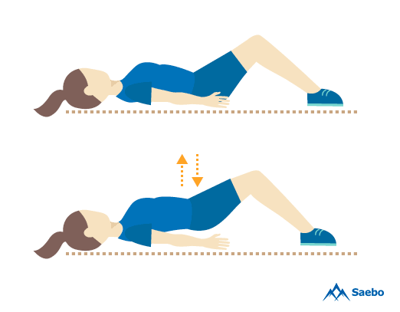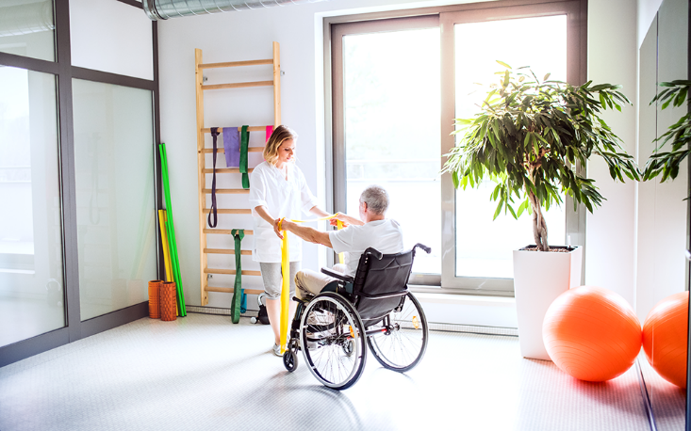
(b) Back stretching (d) Standing attempts

